## **Q2 Creation, Planning, and Preparation**

## 

## EG 8-9: Streaming Tools

## 

## Experience 1: Activity 1

1To know more about the streaming software, read [WIKI: Broadcasting Software](https://docs.google.com/document/d/1Ot7dOsc3SetbAaMZXrZRHuPA4OGFKwnnuj-9kyHZXXk/edit?usp=sharing) and explore the different software.

1. You can also follow these How-Tos in order to explore the software:

[How-To: Streaming Using Chromebook](https://docs.google.com/document/d/1Zgq3gtVOk8nCWMYh6qMI4bJm4nVuFIv2Qq3PsVnlU9A/edit?usp=sharing)

[How-To: OBS Studio](https://docs.google.com/document/d/1mUH5zOGU6_7yRbl5e86_VPn5Fy93bYWtjK24WCDWxP4/edit?usp=sharing)

After that, have your group meet with another group through Google Meet.

1. Choose a broadcasting software that you think is the best to use. Wire cast, vMix, VidBlasterX, OBS Studio, Streamlabs OBS, FFmpeg, XSplit Broadcaster.
2. Have a 30-minute discussion with the other group on the best broadcasting software. <https://streamlabs.com/>.
3. Make sure to continuously ask questions to the other group regarding the software.✅

## Experience 2: Activity 2

Use the steps of Basic Research to find out the different basic equipment used in streaming.

1. Use the Ideate tools to brainstorm with your groupmates on which of the equipment will be used in your stream.camera,mic or microphone, lighting, and a stable internet connection, laptop or computer.
2. Note that you do not need to buy new equipment. You just need to utilize and maximize the equipment available for you. For example, you are not required to buy a mechanical keyboard if you already have a regular one.
3. List down the equipment you will be using and explain why you chose those equipment.camera to see you, mic or microphone to hear you, stable connection to not interrupt your stream, laptop or computer to start your stream.
4. Determine the strengths and weaknesses of those equipment. Blurred camera, mic or microphone, Cheaper models can produce a small amount of noise from the electronics.Higher price – The laptops are costly as compared to PC, because the smaller.
5. Submit your work in the LMS.

EG 10: What’s Your Content

## Experience 1: Activity 1

Read the following to recall the Ideate Tools:

* [WIKI: Design Thinking](https://docs.google.com/document/d/1E4WSPpAMvVb6a-6xBNTCxEG9bYvSbd8mNsrmu1Rgpuw/edit?usp=sharing)
* [How-To: Fishbone Diagram](https://docs.google.com/document/d/1iqbqvzDcG_JyAzNHAVn6j51TIeA4qoBnoM6-q22jZ5w/edit?usp=sharing)
* [How-To: 5 Whys](https://docs.google.com/document/d/1mcq5Tl8rPE-8aPeVXYpeJv2plDTYDxH4oqFgUhLwUfs/edit?usp=sharing)
* [How-To: Mind Mapping](https://docs.google.com/document/d/1-lWfWua_YkfgCSDHDDNOj2hsAYSnkVGiuzgTfCVFWjg/edit?usp=sharing)

1. Brainstorm with your groupmates on the type of streaming content you will be having. Mobile Game Content.
2. Use the ideate tools to decide.Mobile games need a cellphone good internet.
3. Make sure everyone in the group is interested in the content type that you will choose.✅
4. Document your brainstorming on your Portfolio (Brainstorming is a technique used by design teams to create ideas for solving specific design problems. Teams address a topic using "How Might We" inquiries under controlled settings and in a free-thinking atmosphere. They generate a large number of ideas and connect them to uncover viable answers.
5. Submit your work in the LMS.

Experience 2: Activity 2

1. Write a paper as if you are trying to sell your stream. I’m gonna focus on my business and I can’t handle my stream so I'm gonna sell it to you.
2. You can include your goals for the stream such as the number of viewers, number of hours, topics and discussions, etc. Performance, conditions, and criteria are all possible components of learning objectives. A performance component is included in all SMART learning objectives. The learner's performance statement specifies what he or she will know or be able to do in various situations.
3. You can also answer this question to help you write your paper: “Why would I watch your stream? What do I need to expect?” I’m gonna watch your stream because I’m learning on your stream.
4. Submit your work in the LMS.

EG 11: Guidelines to keep in Mind

## Experience 1: Exercise 1

Read the [Data Privacy Act of the Philippines](https://www.privacy.gov.ph/data-privacy-act/)

1. Read and assess the given situations.
2. Determine:

* What was violated
* Why it was violated
* What the victim should know
* The punishment to be given to the violator

Situation 1:

Joelle was asked by At Your Survey, a survey company, to answer a survey for a study as she was randomly selected. They assured her that her private information will only be used for the survey. Trusting that, she provided her name, birthday, contact number, religious organization, political affiliations, and address. However, a week after, Joelle continuously receives texts from a business, promoting their company. She suspects that At Your Service gave away her information as she did not give it to anyone other than that.

**Situation 2:**

Drew just got his driver’s license and with so much excitement, he posted a picture of it on his social media account without covering all the sensitive information. After 2 months, he saw a photo of his Driver’s license on a page telling that people should not buy from his online shop as he is a scammer. Confused, because he doesn’t even have an online shop, he asked the Cybercrime division to investigate the matter. It turns out that someone used his driver’s license as proof of identification in order to scam buyers.

Situation 3:

Ivanne started doing a stream of her playing Valorant. Even though she is a minor, she showed her face, thinking that it would not do her any harm. However, one of the viewers recorded the stream and posted it on another social media platform. Now, as people are anonymous online, they started to criticize her looks. Ivanne wants to take the video down but the uploader would not reply to her.

As a minor, complete the table below by listing down the do’s and don’ts in streaming based on what you have learned from the Data Privacy Act.

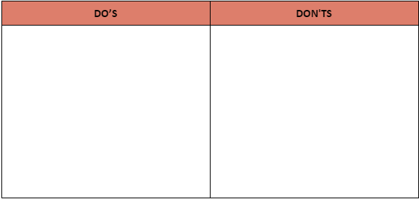

DO’S

Situation 1:Get away if the survey is suspicious.

Situation 2:Cover all of the important information on your post if it is neccesary.

Situation 3:Don’t show your face in your stream if you can’t accept all of the harmful comments to you.

DON'TS

Situation 1:Don’t give all of your information to those surveys.

Situation 2:Don’t post your personal information on social media.

Situation 3:Don’t notice all of the bash.

EG 13: Steam Outline

## Experience 1: Activity 1

1. Create a detailed outline of the events, topics, and discussions that you want to cover in your stream.
2. You can do any format of the outline, such as flow charts, mind maps, storyboards, 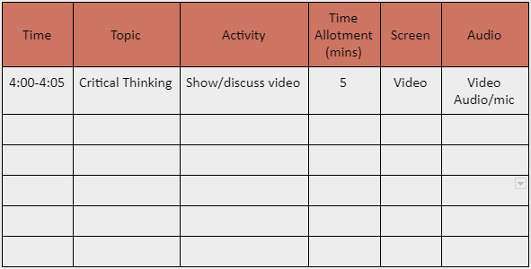etc. as long as it is clear enough to understand. You may also follow this format if you want:

3. You may refer to these [guide questions](https://docs.google.com/document/d/1lq8XnQ93peW5T_MIcn9NtEBAj3sJ17YQg91Tzq24-1A/edit?usp=sharing) to help you start planning.

4. Submit your work in the LMS.

## Experience 2: Activity 2

You can also read the following to know more about how you can promote your stream.

* [41 Ways To Promote Your Stream](https://theemergence.co.uk/41-ways-to-promote-your-stream/)
* [How to promote your Twitch channel](https://www.agilitypr.com/pr-news/public-relations/how-to-promote-your-twitch-channel/)

1. Create promotional materials, spiels, social media accounts you will use to promote your stream.
2. Create an outline of your promotional plan.Step 1: Make it super easy to find the critical details of your event, Schedule your live stream, Announce it on social media,Post in communities, Build a social army, Set up an event, Share info in a podcast,Write a blog post, Post teaser videos.
3. Compile all the promotional materials such as videos, posters that you will post on social media, etc.Include your URL – for example, Facebook.com/YourBrandName – in your posters for the simplest approach to promote your social network page using posters. You can also include a call to action to entice potential followers to act. This procedure is not only simple and inexpensive, but it is also extremely successful.
4. Submit your work in the LMS.

EG 14: Document It on your Website

## Experience 1: Activity 1

Create a web design for your website. You can use Google Slides, Canva, or any application of your choice that will be most convenient for your group.

You may use the following references as your guide:

* [How To: Colors Schemes in Web Design](https://docs.google.com/document/d/1NynTbcoUd78zS0mEbcdyhFCsYyoSGLq_UeSms1v-RgQ/edit?usp=sharing)
* [How To: Fonts in Web Design](https://docs.google.com/document/d/1fwU-c6MOJb7wGY23RyFZku9aW492p5ZdGF4zlzTFw34/edit?usp=sharing)
* [Reference: Elements of a Web Design](https://drive.google.com/file/d/1Hlt5IN7AdTpDlfK-PQ9mUSShe69te-Nw/view?usp=sharing)
* [Reference: Top 6 Basic Elements of Web Design](https://drive.google.com/file/d/1BZi28Z2e7vjwfVt9roTooQWsdv3Lq73L/view?usp=sharing)
* [Reference: Using F and Z Patterns](https://drive.google.com/file/d/1F6dUELMMOfd5pOwrkZCe-JTAAS7piVU0/view?usp=sharing)

Submit your work in the LMS.